Diversity and Inclusion 100 Book Challenge
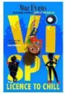 | 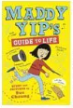 |  | 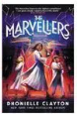 | 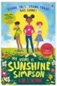 |  | 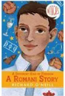 | 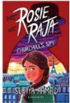 | 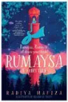 | 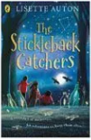
Vi Spy  Maz Evans | Maddy Yip’s Guide to Life  Sue Cheung | Marie Curious – Girl Genius  Chris Edison | The Marvellers  Dhonielle Clayton | My Name Is Sunshine Simpson  G M Linton | PAWS  Kate Foster | A Roman Story  Richard O’Neill | Rosie Raja – Churchill’s Spy  Sufiya Ahmed | Rumaysa  Radiya Hafiza | The Stickleback Catchers  Lisette Auton
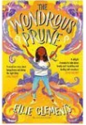 | 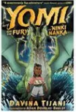 | 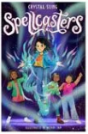 | 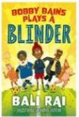 | 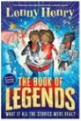 | 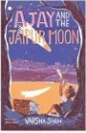 | 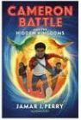 | 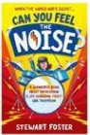 | 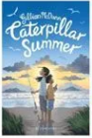 | 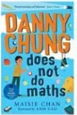
The Wondrous Prune  Ellie Clement | YOMI  Davina Tijani | Spellcasters  Crystal Sung | Bobby Bains Plays a Blinder  Bali Rai | The Book of Legends  Lenny Henry | Ajay and the Jaipur Moon  Varsha Shah | Cameron Battle  Jamar Perry | Can you feel the noise?  Stewart Foster | Caterpillar Summer  Gillian McOwen | Danny Chung does not do maths  Maisie Chan
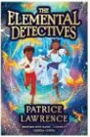 | 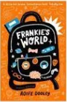 | 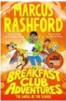 | 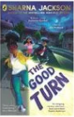 | 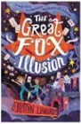 | 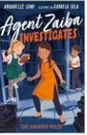 | 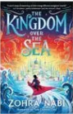 |  | 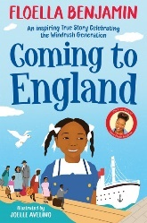 | 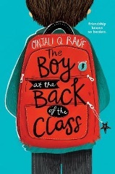
The Elemental Detectives  Patrice Lawrence | Frankie’s World  Aoife Dodley | The Breakfast Club Adventures  Marcus Rashford | The Good Turn  Sharna Jackson | The Great Fox Illusion  Justyn Edwards | Agent Zaiba Investigates  Annabelle Sami | The Kingdom over the sea  Zohra Nabi | Kyan Green  Colm Field | Coming to England  Floella Benjamin | The Boy at the Back of the Class  Onjali Rauf

