Early Readers 100 Book Challenge
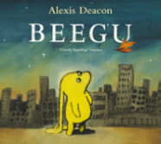 |  |  | 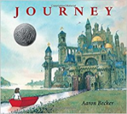 | 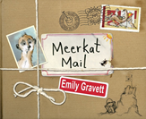 | 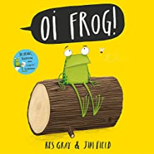 | 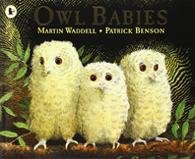 |  | 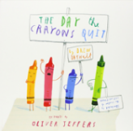 | 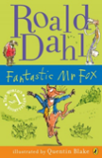
Beegu | Each Peach Pear Plum | Hairy Maclary | Journey | Meerkat Mail | Oi Frog | Owl Babies | Six Dinner Sid | The Day The Crayons Quit | The Fantastic Mr Fox
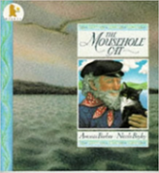 | 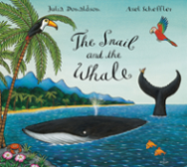 |  |  | 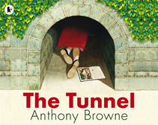 | 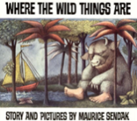 | 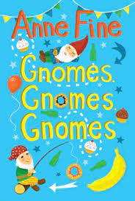 | 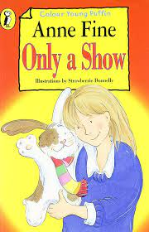 | 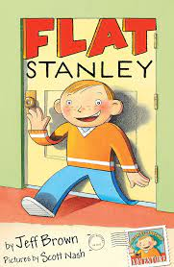 | 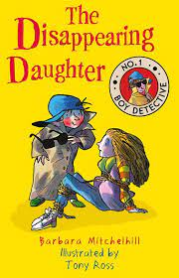
The Mousehole Cat | The Snail and the Whale | The Tin Forest | The Tiger Who Came To Tea | The Tunnel | Where The Wild Things Are | Gnomes, Gnomes, Gnomes | Only a Show | Flat Stanley | The Disappearing Daughter
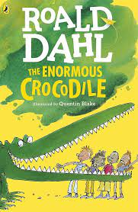 | 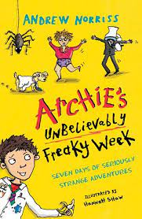 | 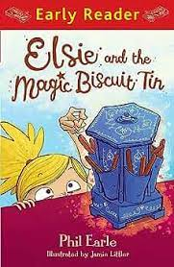 | 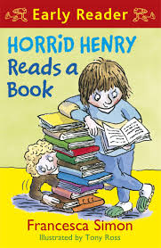 | 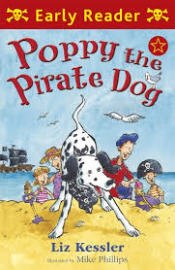 | 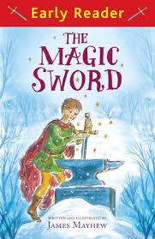 | 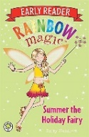 | 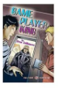 |  | 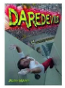
The Enormous Crocodile | Archie’s Unbelievably Freaky Week | Elsie and the Magical Biscuit Tin | Horrid Henry Reads a Book | Poppy the Pirate Dog | The Magic Sword | Rainbow Magic | Game Player | Hitting the Basket | Daredevil
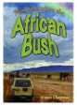 |  | 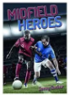 |  |  | 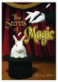 | 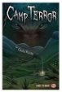 | 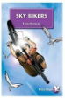 |  | 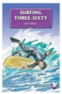
African Bush | ICE | Midfield Heroes | Fighter Planes | Sherlock Holmes | The Secrets of Magic | Camp Terror | Sky Bikers | Something in the Kitchen | Surfing Three-Sixty
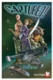 | 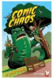 | 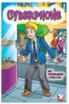 | 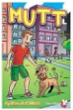 | 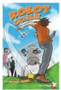 | 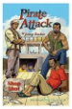 | 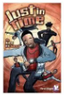 |  |  | 
Captures | Comic Chaos | Cyberphone | Mutt | Robot Goalie | Pirate Attach | Just in Time | Pedal Power | James Bond | Himalayas
 | 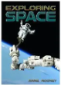 |  | 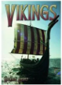 |  | 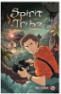 | 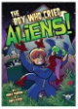 | 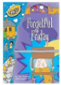 |  | 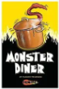
Comic Characters | Exploring Space | Tiny but Deadly | Vikings | Weed Killers | Spirit Tribe | The boy who cried aliens | Forgetful Friday | A Very Special Guest | Monster Diner
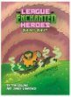 | 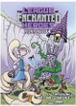 | 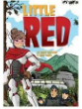 | 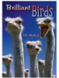 |  | 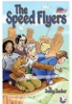 |  | 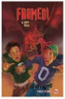 | 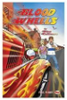 | 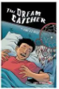
League Enchanted Heroes | League Enchanted Heroes | Little RED | Brilliant Birds | Super Teacher | The Speed Flyers | Ed and the Shirtmakers | Framed | Blood Wheels | The Dream Catchers
 | 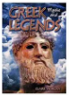 |  |  |  | 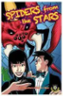 | 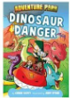 |  |  | 
The history of cats and dogs | Greek Legends | World’s Tallest Buildings | Shocking con tricks | Greatest Speeches | Spiders from the stars | Dinosaur Danger | Pink Football Boots | Alien Speed Smash | The Incredible Save
 |  | 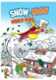 | 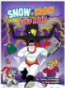 | 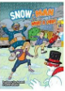 | 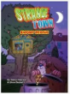 | 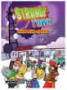 | 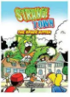 | 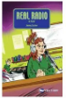 | 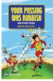
Alien Sports TV | Mystery in Mexico | Snow-Man | Snow-Man | Snow-Man | Strange Town | Strange Town | Strange Town | Real Radio | Your passing was rubbish
 |  | 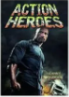 | 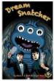 | 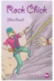 |  |  |  |  | 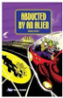
Dark Star | Amazing Racing | Action Heroes | Dream Snatcher | Rock Chick | Snowboard Adventure | Goalkeepers | Mer-boy | Kelly’s Diary | Abducted by an alien

